**Design & Technology**

**

**Composites**

**Materials required for questions**

* Pencil
* Rubber
* Calculator

**Instructions**

* Use black ink or ball-point pen
* Try answer all questions
* Use the space provided to answer questions
* Calculators can be used if necessary
* For the multiple choice questions, circle your answer

**Advice**

* Marks for each question are in brackets
* Read each question fully
* Try to answer every question
* Don’t spend too much time on one question

**Good luck!**

**Q1.** Which composite is widely used in aerospace due to its exceptional strength-to-weight ratio and mouldability into complex shapes?

**A** Glass Reinforced Plastic (GRP)

**B** Carbon Fibre Reinforced Plastic (CFRP)

**C** Fibre Cement

**Q2.** What property makes GRP (glass reinforced plastic) suitable for boat hulls and swimming pools?

**A** High thermal conductivity

**B** Corrosion resistance and water impermeability

**C** Magnetic properties

**Q3.** Reinforced concrete is preferred over plain concrete for structural columns because it:

**A** Enhances tensile strength with steel reinforcement

**B** Reduces material costs

**C** Improves thermal insulation

**Q4.** Engineered wood like glulam (glued laminated timber) is used for curved beams in buildings because it:

**A** Is cheaper than solid wood

**B** Degrades faster than traditional timber

**C** Combines layers for increased strength and flexibility

**Q5.** Explain why tungsten carbide is an appropriate material for the manufacture of a centre lathe cutting tool **(6 marks)**

**Q6.** Define the term ‘composite’ **(2 marks)**

**Q7.** Name a specific application for each of the following composites **(3 marks)**

Aluminium composite board

Glass reinforced polymer (GRP)

Glulam

**Q8**. Explain why concrete is a suitable material for the manufacture of the outdoor table tennis table shown **(6 marks)**

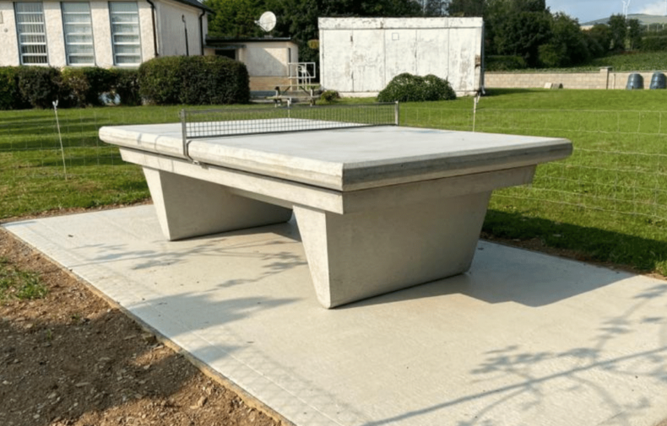

**Answers**

**Q1**. B

**Q2**. B

**Q3**. A

**Q4**. C

**Q5**.

* The combination of tungsten and carbon produces a hard material which will allow the cutting tool to resist the wear associated with cutting a rotating material.
* Tungsten carbide can maintain a sharp tool edge for longer while producing a better-quality finish.
* Tungsten carbide is an extremely hard material so is suitable for use on a wide range of softer metals.
* Tungsten carbide has good corrosion resistance which enables it to be used with a range of lubricants and coolants.
* Tungsten carbide can be formed by sintering into an appropriate shape for the cutting tool tip.
* The porous nature of sintered product can assist cutting when using a lubricant.
* Tungsten carbide is dimensionally stable at high temperatures associated with friction involved with cutting and shaping materials.

**Q6.**

One mark for a simple definition:

* A composite is a material comprised of two or more different materials.

Two marks for a detailed definition:

* The material formed makes use of the properties of the two original materials to produce a new material with enhanced properties.

**Q7.**

Aluminium composite board:

* indoor and outdoor signage
* applications that use their sound absorbing properties such as panels in vehicles
* architectural cladding.

Glass Reinforced Polymer (GRP):

* boats, canoes, jet skis
* vehicle body work
* coatings on sports equipment such as hockey sticks.

Glulam:

* engineered beams
* bridges
* architectural timber framework.

**Q8.**

* Concrete is a hard material that can be polished to provide a smooth, hardwearing playing surface.
* Concrete can be reinforced with a high tensile steel frame to provided additional strength for the unsupported table.
* Concrete can be easily poured into a simple mould to create the shape of the table.
* Concrete can be moulded on site removing the need to transport and lift the table.
* Concrete is a stable material that can withstand weathering and changes in temperature making it suitable for outdoor use.
* Concrete is hard and rigid providing an appropriate surface with no flex. • Concrete requires little maintenance.
* Concrete is a durable material that will withstand potential inappropriate use or vandalism.
* The use of concrete provides a flat playing surface.